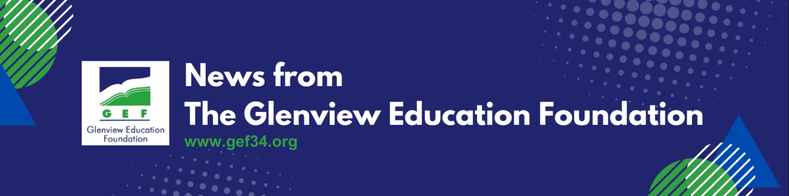
The GEF Spring Grant Application Is Open!

Please submit your application before Monday March 9, 2026.
The Glenview Education Foundation (GEF) is a volunteer-run organization whose mission is to fund innovative pilot projects and grants from our dedicated faculty, staff and administrators that drive our district forward. You may even know and love some of our most popular grants like Maker Modules, Flexible Learning Spaces, GEF Recital Night, and STEM Night! You can see more of our grants at gef34.org/grants!
GEF is looking to fund grants that are innovative, and correspond to curriculum enrichment, educator growth and/or community involvement initiatives this Fall. Teachers and administrators of District 34 are encouraged to submit grant applications for their ideas to help our district grow. Our dedicated liaisons are always available to help guide applicants through the process and help fine tune ideas. Please reach out to them with any questions you may have and they will be happy to help.

GEF Grant Liaisons are available to help:
- Christina Leong - Lyon
- Erin Rasler - Pleasant Ridge
- Nikki Reams - Henking
- Jessica Gebauer - Hoffman
- Allie Dawson - Westbrook
- Tina Parekh - Glen Grove
- Gina Milanesio - Attea
- Lisa Pavic - Springman

​
Thank you to all of our schools for welcoming our presentations about GEF’s mission and grant application process. In case you missed it, here are the presentations for GEF grants:
Grades K-2 GEF Presentation: https://bit.ly/3EREMOF
Grades 3-5 GEF Presentation: https://bit.ly/3EVr5OR
Grades 6-8 GEF Presentation: https://bit.ly/45bplvs
